Practical no.09

Title of the Assignment: Data Visualization II

1. Use the inbuilt dataset 'titanic' as used in the above problem.

Plot a box plot for

distribution of age with respect to each gender along with the information about whether they

survived or not. (Column names : 'sex' and 'age')

1. Write observations on the inference from the above statistics.

import seaborn as sns import matplotlib.pyplot as plt

titanic_df = sns.load_dataset('titanic') titanic_df.head()

|  |  |  |  |  |
| --- | --- | --- | --- | --- |
| survived pclass sex age sibsp parch fare embarked | | | | |
| class \ | | | | |
| 0 |  | 0 3 male 22.0 1 | 0 7.2500 | S |
| Thir | | | | |
| 1 |  | 1 1 female 38.0 1 | 0 71.2833 | C |
| Firs | | | | |
| 2 |  | 1 3 female 26.0 0 | 0 7.9250 | S |
| Thir | | | | |
| 3 |  | 1 1 female 35.0 1 | 0 53.1000 | S |
| Firs | | | | |
| 4 |  | 0 3 male 35.0 0 | 0 8.0500 | S |
| Thir | | | | |
| 0  1  2  3  4 | who man woman False woman True woman False  man | adult_male deck embark_town alive True NaN Southampton no  False C Cherbourg yes False NaN Southampton yes False C Southampton yes  True NaN Southampton no | alone False  True |  |

sns.set(style="whitegrid") plt.figure(figsize=(10, 6))

sns.boxplot(x='sex', y='age', hue='survived', data=titanic_df, showfliers=False)

plt.title('Age Distribution with Respect to Gender and Survival Status')

plt.xlabel('Gender') plt.ylabel('Age') plt.show()

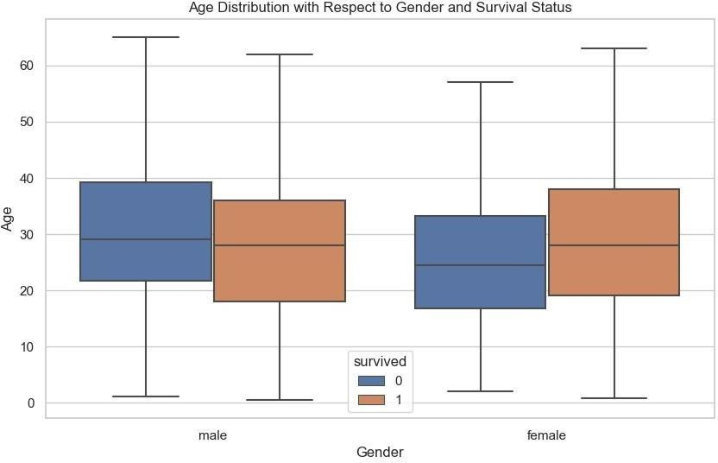

Name: Vaishnavi Jagtap

Roll no: 13208

Batch: B1